**MySQL SetUp**

**Step 1: Download MySQL**

Go to the MySQL website: Visit MySQL Community Downloads.

Select your OS: Choose the appropriate version for your operating system (Windows, macOS, Linux, etc.).

Download the installer: Click on the recommended download link to get the installer

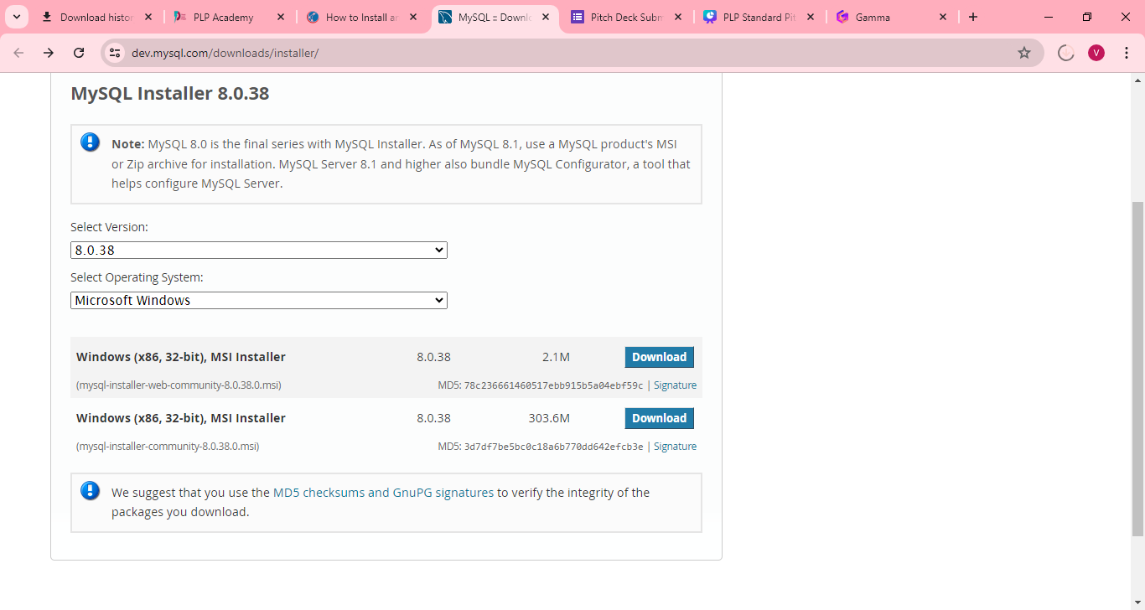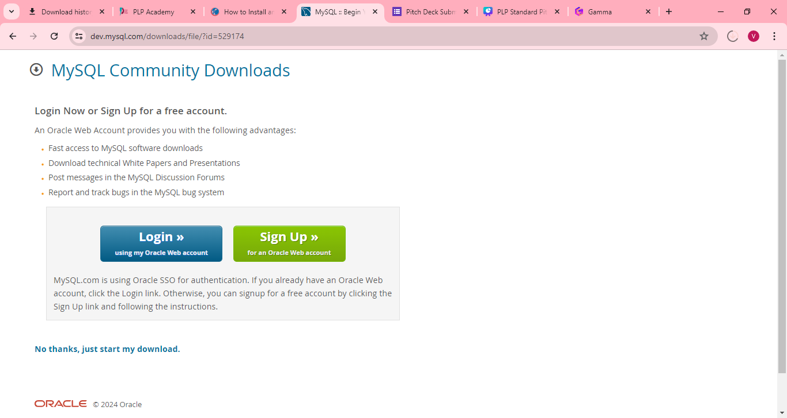

**Step 2: Install MySQL**

Run the installer: Once downloaded, open the installer file.

Choose setup type: Select the installation type. For most users, "Developer Default" is recommended.

Check requirements: The installer will check for required software. Install any missing requirements.

Installation: Click "Next" and then "Execute" to start the installation process.

**Step 3: Configure MySQL Server**

**Step 4: Initialize MySQL**

Apply Configuration: Review your settings and click "Execute" to apply them.

Complete Installation: Finish the setup and close the installer.

**Step 5: Verify MySQL Installation**

Open MySQL Command Line:

On Windows, search for "MySQL Command Line Client".

On macOS/Linux, open Terminal and type mysql -u root -p.

Login: Enter the root password set during installation.

**Step 7: Connect to MySQL**

Using Command Line: *‘mysql -u root –p’*

**MySQL Setup Challenges and Strategies**

**Challenge 1: Missing Dependencies**

Issue: During installation, the MySQL installer may indicate missing dependencies or required software components.

Strategy: Ensure all prerequisite software, such as the Microsoft Visual C++ Redistributable, is installed. The MySQL installer typically provides download links for these dependencies. Install the necessary components and then resume the MySQL installation.

**Challenge 2: Authentication Errors**

Issue: Users might encounter authentication errors when trying to log in to MySQL after installation.

Strategy: Ensure that the root password is correctly set during the installation process. If authentication errors persist, rerun the security script (mysql_secure_installation) to reset the root password and configure security settings. Double-check for typographical errors when entering the password.

**Git Set UP**

**Step 1: Download Git**

Go to the Git website: Visit Git Downloads.

Select your OS: Choose the appropriate version for your operating system (Windows, macOS, Linux, etc.).

Download the installer: Click on the download link to get the installer.

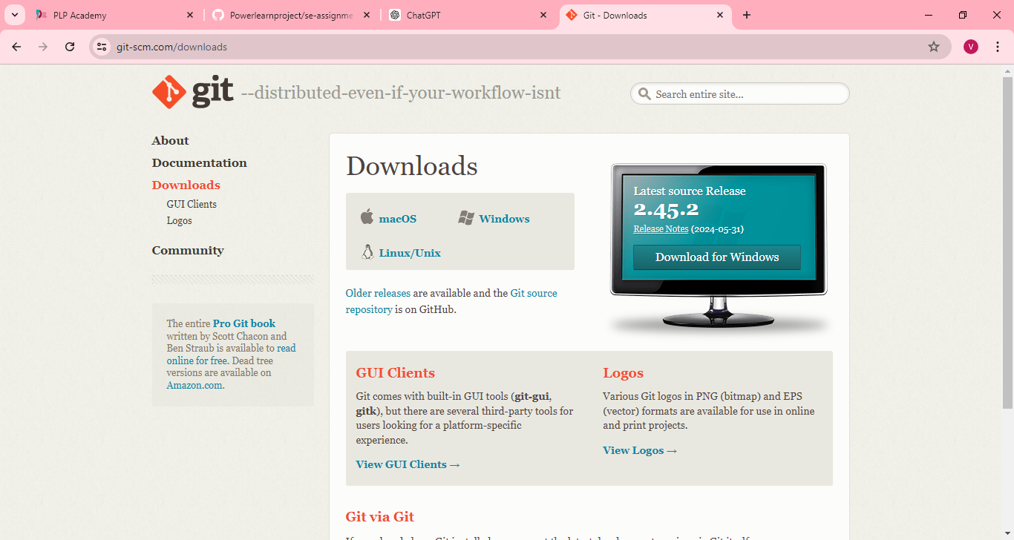

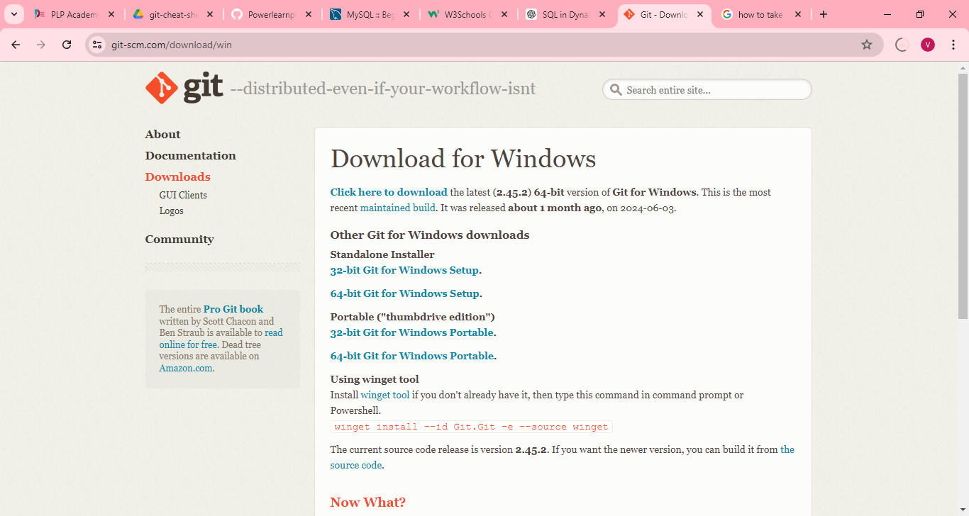

**Step 2: Install Git**

Run the installer: Once downloaded, open the installer file.

Setup Wizard: Follow the instructions in the setup wizard.

Adjust Settings

**Step 3: Verify Git Installation**

Open Terminal (Command Prompt/Git Bash):

On Windows, search for "Git Bash" or "Command Prompt".

On macOS/Linux, open Terminal.

Check Git Version: Run the command: *‘git –version’*

**Step 4: Configure Git**

Set Global Username: *‘git config --global user.name "Your Name" ‘*

Set Global Email: *‘git config --global user.email* [*youremail@example.com*](mailto:youremail@example.com) *‘*

Verify Configuration: Run the command to check your settings: *‘git config –list’*

**Git Setup Challenges and Strategies**

**Challenge 1: PATH Configuration Issues**

Issue: After installation, Git commands may not be recognized in the terminal, indicating that the PATH environment variable is not set correctly.

Strategy: During installation, ensure that the option to add Git to the system PATH is selected. If this step is missed, manually add the Git binary path to the system PATH environment variable. For Windows, go to System Properties > Environment Variables and add the Git binary path to the PATH variable.

**Challenge 2: SSH Key Configuration**

Issue: Users may face difficulties in generating and configuring SSH keys for GitHub/GitLab/Bitbucket, resulting in authentication issues.

Strategy: Follow a detailed guide for generating SSH keys and ensure the correct steps are taken to add the key to the SSH agent. Copy the SSH key correctly and paste it into the appropriate settings on GitHub/GitLab/Bitbucket. Use ssh -T git@github.com (or the appropriate host) to test the connection and ensure that SSH keys are configured correctly.

**VS code Set UP**

**Step 1: Download VS Code**

Go to the VS Code website: Visit Visual Studio Code Download.

Select your OS: Choose the appropriate version for your operating system (Windows, macOS, Linux).

Download the installer: Click on the download link to get the installer.

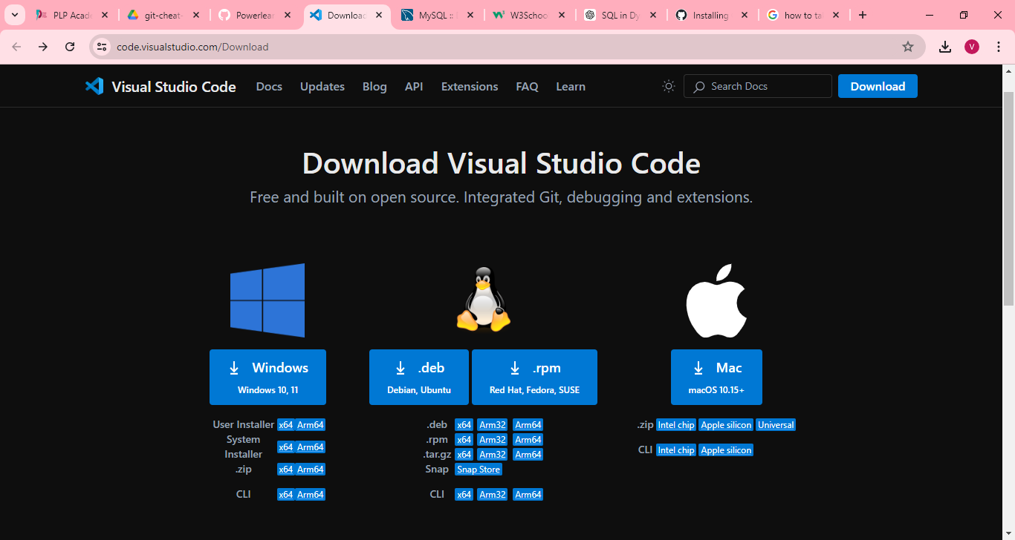

**Step 2: Install VS Code**

Run the installer: Once downloaded, open the installer file.

Setup Wizard: Follow the instructions in the setup wizard.

Accept the Agreement: Review and accept the license agreement.

Select Destination Location: Choose the installation location or leave it at the default path.

Select Additional Tasks

Install: Click "Install" to complete the installation process.

Launch VS Code: Check "Launch Visual Studio Code" and click "Finish."

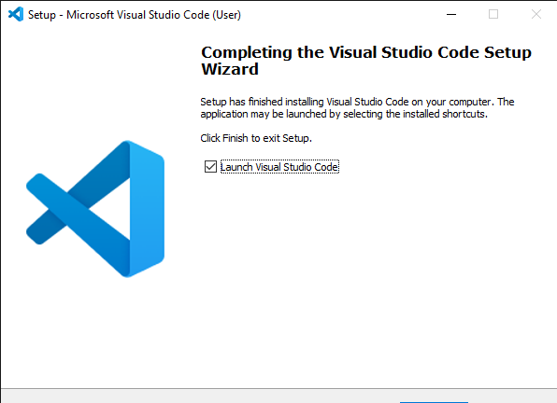

**VS Code Setup Challenges and Strategies**

**Challenge 1: Extension Installation Errors**

Issue: Some users may experience errors or failures when trying to install extensions from the marketplace.

Strategy: Check internet connectivity and ensure that VS Code can access the extension marketplace. If the problem persists, try installing the extensions manually by downloading the .vsix files from the marketplace website and using the Extensions: Install from VSIX... command in the Command Palette.

**Challenge 2: Debug Configuration Issues**

Issue: Setting up the debug configuration for specific programming environments can be challenging, especially for beginners.

Strategy: Refer to the official VS Code documentation or the documentation of the specific extension for detailed setup instructions. Use predefined configurations available in the launch.json template and customize them as needed. Seek help from community forums or online resources specific to the programming language or framework in use.